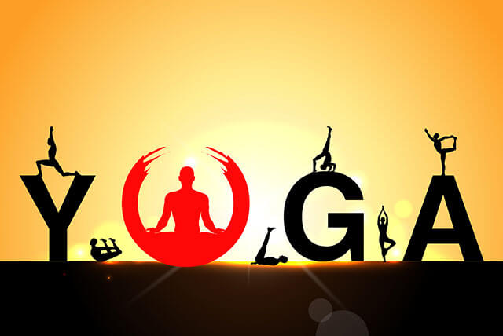
International Yoga Day is observed on 21st June every year to spread awareness about the importance and effects of yoga on the health of the people. The word 'yoga' is derived from Sanskrit which means to join or to unite.
Yoga is an ancient physical, mental and spiritual practice which gives calmness, peace, confidence and courage to the people through which they can do several activities in a better way. At every level of existence it is a state of harmony. Yoga is practiced in various forms around the world.
International Day of Yoga 2018: Theme
The International Day of Yoga 2018 theme is 'Yoga for Peace' which is organized by the permanent mission of India to the United Nations.
Objectives of International Yoga Day
- Make people aware about the benefits of yoga and connect them with nature.
- To reduce the rate of health-challenging diseases in the world.
- Spreading growth, development and peace throughout the world.
- Making people aware about physical and mental illnesses and providing solutions through yoga.- It also aims to develop a habit of meditation for peace of mind, self-awareness which is necessary to survive in a stress-free environment.

